
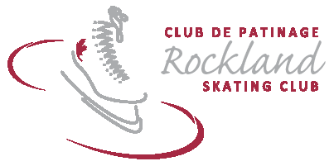

2017- 18 TEEN/ADULT/OPEN SKATING REGISTRATION FORM
November 2, 2017 – March 31, 2018

Skater’s Name: ____________________________________Address:_______________________________________ Postal Code: ____________________

D.O.B.(YYYY/MM/DD): ____________________ Health Card #: ______________________Skate Canada #: ______________ Home Club:______________

Name of Parent(s) or Guardian(s): _____________________________________ Telephone: (Day) _____________________ (Evening)_______________

Postal Code: _____________________________ E-Mail Address:_________________________________________________________________________

Do you or your child have any medical conditions? Yes __ No__ If yes, please describe:_______________________________________________________

Publicity Waiver: I understand that the Rockland Skating Club may use photographs of the participants during Club activities for social media and promotional purposes. Unless advised otherwise, I accept that my or my child’s photograph may be used for promotional purposes. Yes_____ No _____

Personal Liability: The applicant, his/her parents or guardian agree that the RSC, its Directors, Volunteers and Coaches, are not liable for, nor hold any responsibility for, any accident or loss however caused. Helmet policy: All CanSkate/Learn to Skate participants must wear CSA approved helmets.

Signature (of parent or guardian if skater is under 18 years of age) ___________________________________________ Date __________________

Spoken language (skater): English __ French __ New registrant: Yes _____ No ______

Session #2 – November 2 – December 21, 2017 Registration deadline: October 30
Thursdays (7 classes) 20 h 05 – 21 h 35 / 8:05 PM – 8:35 PM |  | $90.00
Subtotal =
Session #23 – January 4 – March 22 2018 - – Registration Deadline: Dec. 22
Thursdays (11 classes) 20 h 05 – 21 h 05 / 8:05 PM – 8:35 PM |  | $140.00
SUBTOTAL =
Family Discount 5% for 2nd family member, 10% for 3rd additional family member | -
Skate Canada Membership Fee ($35.65) + RSC Administration Fee ($9.35) - Yearly non-refundable | +$45.00
Late fee (if received after the registration deadline) $20.00 | +
Total Amount Due =
Refund policy: Refunds will be issued by written request to RSC with a medical certificate only and pro-rated based on the number of sessions remaining .

**RSC reserves the right to make fee and program changes and/or cancellations due to insufficient registration.

FOR CLUB USE ONLY:

Cheque Dates (D/MM/YY) | #1 | #2
Cheque Amount/Number
Cash: |  | Discount Applied:
Program(s): |  | Registrant’s Name:

