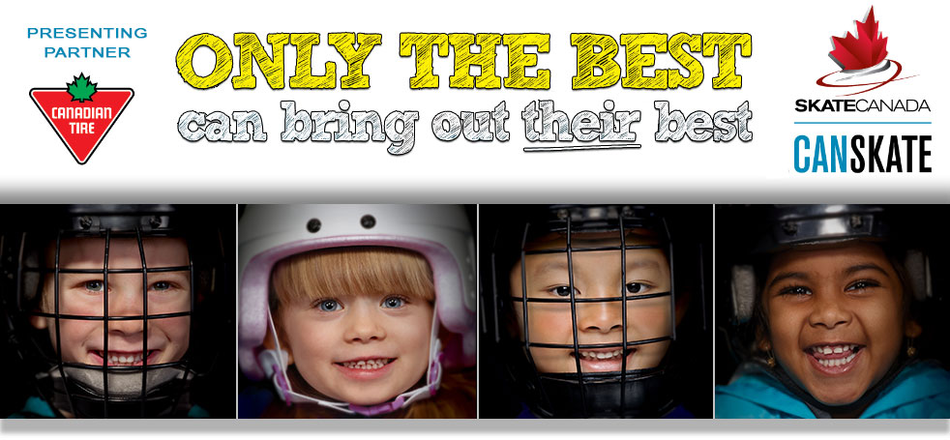

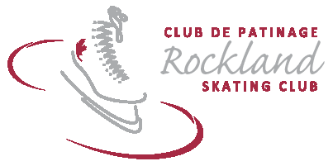

2017-2018 CANSKATE REGISTRATION FORM

Skater’s Name: ____________________________________Address:______________________________________ ____________________

D.O.B.(YYYY/MM/DD): ____________________ Health Card #: ______________________Skate Canada #: ______________ Home Club:______________

Name of Parent(s) or Guardian(s): _____________________________________ Telephone: ____________________________________

Postal Code: _____________________________ E-Mail Address:_________________________________________________________________________

Does your child have any medical conditions? Yes __ No__ If yes, please describe:____________________________________________________________

Publicity Waiver: I understand that the Rockland Skating Club may use photographs of the students during Club activities for promotional purposes and social media. Unless advised otherwise, I accept that my child’s photograph may be used for promotional purposes. Yes_____ No _____

Personal Liability: The applicant, his/her parents or guardian agree that the RSC, its Directors, Volunteers and Coaches, are not liable for, nor hold any responsibility for, any accident or loss however caused. Helmet policy: All CanSkate participants must wear CSA approved helmets.

Signature (of parent or guardian if skater is under 18 years of age) ___________________________________________ Date __________________
Spoken language (skater): English __ French __ New registrant: Yes _____ No ______
Highest Canskate stage passed (please circle): P 1 2 3 4 5 Agility / Balance / Control
CanSkate Session #1: 9 September to 30 October 2017 – Registration Deadline: September 7
Sept 11 – Oct 30 - Monday (7 sessions) 18h25 – 19h10 / 6:25PM – 7:10PM  Sept 9 – Oct 28 - Saturday (8 sessions) 9h15 – 10h00 / 9:15 AM – 10:00AM | $ 122.50 □  $ 140.00 □
+ Fundraising (raffle tickets) $20.00 for first child, $20.00 for second child (+)Add →
CanSkate Session #2 : 4 November to 23 December 2017 – Registration Deadline: October 30
Nov 6 – Dec 18 - Monday (7 sessions) 18h25 – 19h10 / 6:25PM – 7:10PM  Nov 4 – Dec 23 - Saturday (6 sessions) 10h00 – 10h30 / 10:00 AM – 10:30AM | $ 122.50 □  $ 105.00 □
+ Fundraising (raffle tickets) $20.00 for first child, $20.00 for second child (+)Add →
CanSkate Session #3 – 6 January – 31 March 2018 - Registration Deadline: January 4, 2018
Jan 8 – Mar 31 - Monday (12 sessions) 18h25 – 19h10 / 6:25PM – 7:10PM (includes Mar 31)  Jan 6 – Mar 31 Saturday (12 sessions) 10h00 – 10h30 / 10:00 AM – 10:30AM | $ 210.00 □  $ 210.00 □
+ Fundraising (raffle tickets) $40.00 for first child, $20.00 for second child (+)Add →
SUBTOTAL OWED =
Family Discount 5% for 2nd family member, 10% for 3rd additional family member |  | -
Full payment discount - Register for two (2) sessions – full payment provided and receive $20.00 off  Register for three (3) sessions – full payment provided and receive $30.00 off |  | -
Skate Canada Membership Fee ($35.65) + RSC Administration Fee ($9.35) - Yearly non-refundable |  | +$45.00
Late fee (if received after the registration deadline) $20.00 |  | +
Total Amount Due =
Refund policy: Refunds will be issued by written request to RSC with a medical certificate only and pro-rated based on the number of sessions remaining.
**RSC reserves the right to make fee and program changes and/or cancellations due to insufficient registration.

Cheque Amount/Number |  |  | Lottery Ticket Numbers:
Cash:
Discount Applied: |  | Registrant’s Name:

